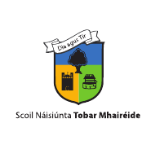
ST MARGARET’S NATIONAL SCHOOL

ENROLMENT APPLICATION FORM
SEPTEMBER 2024
Please return this form via email only to stmargaretsns@hotmail.com

Please note: closing date for applications 6th February 2024.

Name of new pupil: _________________________________

Pupil’s Date of Birth: __________________________

Mother’s name: ______________________________

Father’s name: _______________________________

Home Address: ____________________________________________________

________________________________________________________________

Contact No: Home __________________ Mobile __________________________

Email address: ______________________________________________________

Has your child any siblings in the school? __________________________________

Is either parent a past pupil of the school? ________________________________

_________________________________________________________________
Signed: ____________________ Date:_____________________________
Parent/Guardian

